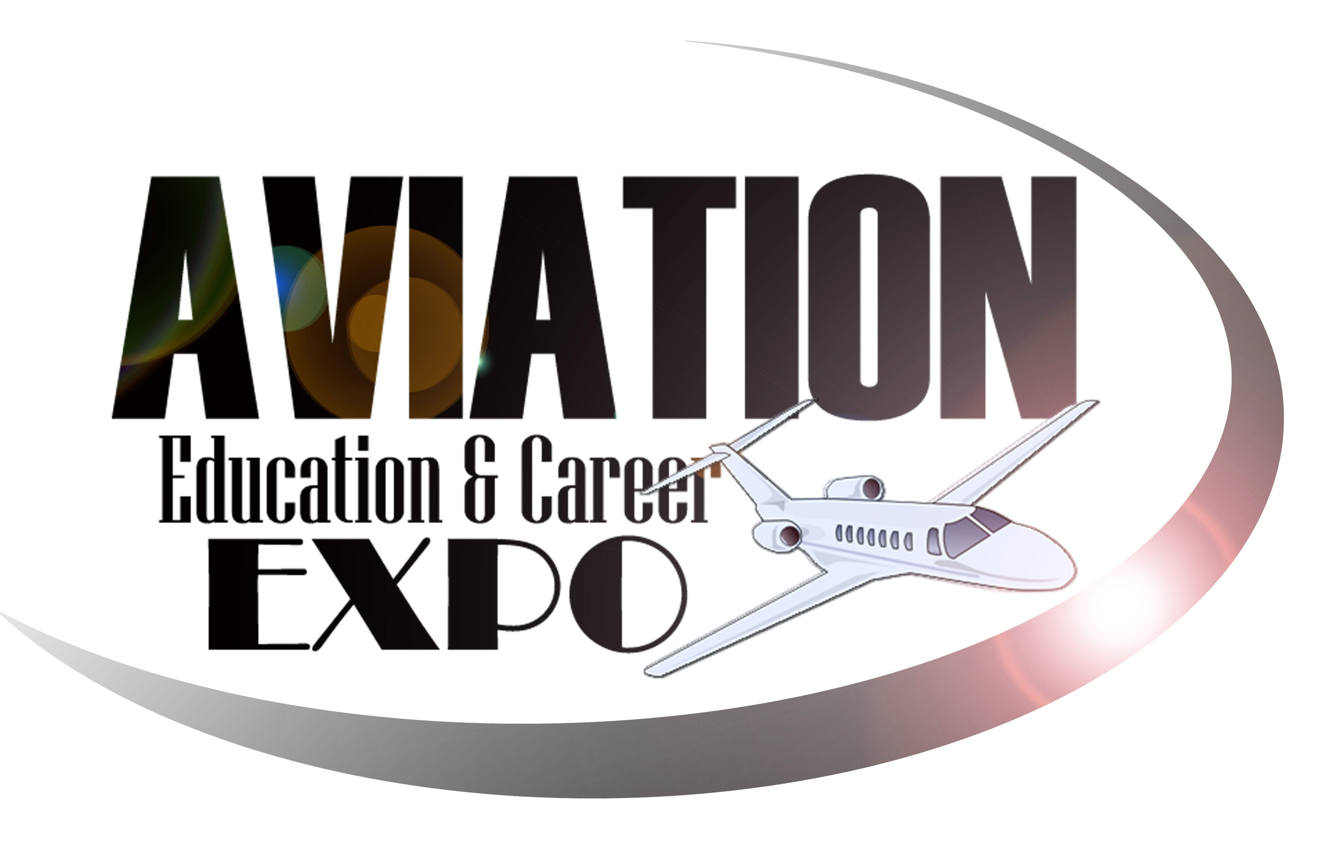
Friday, November 3rd, 2023
Leesburg Executive Airport -957 Sycolin Rd.- Leesburg, VA 20175
703.889.8558 expo@projetaviation.com

Dear Participating Schools/Educators:

The registration you have been waiting for! You are invited to attend the 17th Annual Aviation Education & Career Expo “EXPLORE BEYOND THE HORIZON”, hosted by ProJet Aviation, in Leesburg, VA. Date: Friday, November 3rd, 2023 (9am – 2pm). This event is geared toward high school and college level students (averaging ages 16-22).

This event is packed with industry leaders, vendors, aircraft displays, guest speakers, demonstrations, internships, and scholarships!

We have distributed over $1.5 Million Dollars in aviation education and flight training awards!
Some of the vendors and careers represented:
NASA * Pilots * Flight Attendants * Medevac Flight Nurses * Avionics Companies * Coast Guard Search & Rescue * Maintenance Mechanics * Air Charter Operators * Homeland Security * NTSB* Air Traffic Controllers* FAA* Military * Aircraft Sales * Publications * Hospitality * Transportation Security * Agricultural Aviation * Flight Instruction * Aviation Fuel * Aerial Mapping * Corporate Flight Departments * In-Flight Catering * Law Enforcement *

The entire day is FREE of charge and includes lunch! Space is extremely limited, and over 100 schools have been invited to hand-select 10-20 students to attend. We ask that you select students that have a sincere interest in this opportunity. Reserved space will be on a first come first serve basis.
Once we have reached max capacity, schools/individuals will be placed on a wait list.

Scholarship essay application packets will be available SOON at www.projetaviation.com click on “Aviation Expo!” We will provide helpful hints, guidance, and tips to be successful throughout the application process. Please encourage your registered students to work on their scholarship applications over the summer and perhaps even make their essays a class project, in the new school year! Scholarships will be awarded during the event and winners must be present!

Sincerely,

Julie O’Brien, Event Coordinator
This form will HOLD seats for your school – Friday, Novmeber 3rd, 2023

STUDENT REGISTRATION – Mandatory to hold space for your school.
Please return at your earliest convenience

Name of School/Homeschool or Individual: ____________________________________________ (Must be 16-22) Any exceptions need prior approval.
Please reserve __________seats for our group. (20 max) per group unless you have received prior authorization.
School Address:_____________________________________________

School Phone: ______________________________

Name of School Official Attending: ______________________________

Cell Phone: __________________________ Email: ________________________
Homeschooled students and independent students may also register. Just indicate that information in your registration.

Please scan and email back to expo@projetaviation.com Registration will be cut off when we reach full capacity. You will be notified if you have been placed on a wait list.

Our Expo committee members represent various careers, experience, and pathways to this exciting industry. If your school would like a visit from our team to speak with your registered students and/or an assembly of interested students, to better help you select your targeted audience to attend, please let us know.

Yes_____ No_____ If you select “YES” we will be in touch with you to schedule a date and time for your school visit – in the Fall.

EXPO TESTIMONIALS…

Please take a moment to read the testimonials below so you understand the impact of this event…

Testimonials:
“Truly one of our pilot’s favorite events to attend! Very impressive how the event just keeps getting bigger!” L. Jakub, Airline Pilots Association

“Each year I attend, I learn so much, and I am grateful for my scholarship which reduced my costs for becoming a commercial pilot. Thank you so much for the energy you expend in supporting young adults pursuing a career in aviation.” Niles S. Scholarship Recipient
“It was amazing to see so many young future aviators in one place. I look forward to returning next year.” J. Ellizson Republic Airlines - Vendor
“If you have students interested in any aspect of aviation, this is one experience you don’t want them to miss. This remarkable 1-day event is the most comprehensive, generous, educational program available to students, like no other. This is a unique and rewarding experience P. Arnold CTC Professor
“This has really opened doors for me, and I would not be where I am now, if it wasn’t for this scholarship.” Paul A. Scholarship Recipient
“Thank you for such an amazing day. Your Expo provided us with new resources and doubled my excitement of what’s possible. Thank you for your efforts and vision. A. Knapp, Student
"The vast amount of information available to our students as they begin career exploration and employment was incredible. Students were able to see that there are a wide variety of careers in aviation as well as understand there are many avenues to pursue these careers. Students were captivated." K. Koops Educator, Frederick County Schools

“The event was incredible! I go to a lot of aviation events and I can say that this is the best I have attended. Thank you for including us!” Andrew L. Vendor

" I really want to thank you for introducing me to the amazing world of aviation. I've accomplished more than I could have possibly imagined in just a couple of years. I have been accepted to Embry Riddle and plan to study Aerospace Science!" T. Botezan, Student

"It's likely that the enthusiasm and quality of students at the Expo had more of an impact on me than I did on them. I haven't encountered a more positive environment resourced for success to those aspiring to a career in aviation than this event in Leesburg!" Guest Speaker, Michael Rutledge, Former Navy SEAL and Army Special Operations Aviator, West Point Military Academy.

